

MINI PROJECT REPORT

“Nalanda Open University

E- Gyan Portal”
Submitted for the partial fulfilment of award of

BACHELOR OF TECHNOLOGY
In
Computer Science & Engineering
By

Mukul Kumar

Bishu Kumar

Ramdatt Bhardwaj

Sanchit

under the Guidance of
Mr. Tarun
&
Course Faculty Mrs. Nisha Vashishth


I.T.S ENGINEERING COLLEGE GREATER NOIDA
February, 2024

DECLARATION

This is to certify that the Seminar Report/ Project Report/ Mini Project Report on “Nou E-gyan Portal” by Mukul Kuamr, Bishu Kumar, Ramdatt Bhardwaj, Sanchit have been submitted for the partial fulfilment of the requirements of B.Tech. in Computer Science and Engineering (CSE) / Data Science (DS). The report is our own work. Also, we certify that it is our original work and free from any plagiarism

Mukul Kumar
Bishu Kumar (2202221540007)
Ramdatt Bhardwaj (2202221540019)
Sanchit(2202221540022)

CERTIFICATE

This is to certify that the Seminar Report/ Project Report/ Mini Project Report on “Nou E-Gyan Portal” by Mukul Kuamr, Bishu Kumar, Ramdatt Bhardwaj, Sanchit have been submitted for the partial fulfilment of the requirements of B.Tech. in Computer Science and Engineering (CSE) / Data Science (DS). The work is carried out under my supervision and free from plagiarism.

Ms. Rakhi Puri Asst. Professor-CSE (Supervisor)

Dr. Ashish Kumar
Head of Department-CSE

ACKNOWLEDGEMENT

I would like to take this opportunity to express my gratitude to everyone who helped me along the way and offered guidance in order for the project "Nou E-gyan potral" to be completed successfully. I owe the success of this project to Mr. Yogesh Sharma , the project guide, for her unwavering support and guidance, which enabled me to successfully navigate the teething issues of an industrial setting and complete the project work on schedule. I am appreciative of every team member who contributed to the project's development. I owe my friends as well, whose encouragement and moral support have always motivated me to do my best. Last but not the least ,my project would not have seen the light of the day without the blessing of my parents which was a constant help in the times of need.

Mr. Yogesh Sharma
(ASSISTANT PROFESSOR) COMPUTER SCIENCE AND ENGINEERING

TABLE OF CONTENT

S. No. | Title
1 | Abstract
2 | About the Project
3 | Objective
4 | Introduction of the Project
5 | Technologies Used
6 | Future Scope

ABSTRACT

This project involves the development of a user-friendly and website designed to cater to diverse user needs. The website aims to provide up- to-date and accurate data and related information to enhance user awareness .

*Real-time Weather Updates: The website will offer real-time information updates, including notice, notifications. Users can rely on accurate and current data to plan their activities and make informed decisions.

.

ABOUT THE PROJECT

This Project is a learning management system. The analysis steps of project are given below:-
- Feasibility Study

Feasibility study is the measure of how beneficial or practical the development of an information system will be to an organization. The Feasibility analysis is a cross life cycle activity and should be continuously performed throughout the system life cycle.

- Operational Feasibility:-

By providing the web based application, all the users will get a very good facility of accessing the service to fulfil their requirements. All the user information, information sharing and selection process is done properly.
Users will feel comfortable by reduction of their work. The system will make handling of large databases easy. Losing of records will be avoided. Considering all these factors, we can conclude that all the users and end users will be satisfied by the system.

- Technical Feasibility:-

For the design and development of the system, several software products have been accommodated.
- Database design – MySQL
- Interface design – HTML, CSS, Java Script and Bootstrap.
- Coding – Java with JSP
The technology (Java with JSP) has enough efficiency for the development of the system. Therefore the project is technically feasible.

- Schedule Feasibility:-

The duration of time required for the project has been planned appropriately and it is the same as the duration of time expected by the client. Therefore the application can be delivered to the client within the expected time duration, satisfying the client. Hence the project is feasible in scheduling.

- Economical Feasibility:-

According to the resources available and the project scheduling process it is estimated that the expenses allocated for the web application to be developed, by the client is sufficient enough. Hence the economical factor has been considered feasible.

- Project Planning & Scheduling:-

Planning is very important part of any software development. In the planning phase we decide which features are to be included in the system to make a good system, how much time do we need to complete the project, what will the cost of the system etc…
A Software Life Cycle or software process is a series of identifiable stages that a software product undergoes during its development. A software product development effort usually starts with a project identification and selection stage and then requirements analysis; design, coding, testing, implementation and maintenance are undertaken.
A life cycle model identifies all the activities required to develop and maintain a software product and establishes a precedence ordering among the different activities.
The various phases of Software Development Life Cycle-

- Requirement Analysis
- System Design
- Coding
- Testing
- Implementation

OBJECTIVE

The NOU e-Gyan Portal is a Learning Management System (LMS) with the objective to facilitate “E-Learning System to the students for the learning purpose from a remote location". The System is Secure, Robust Web Application for E-Learning. It has been designed to provide online study material to the students of Nalanda Open University (NOU). The portal is user friendly & easy to access. The whole LMS deployment is on cloud-based architecture so that its resources can be elastic as and when required. The NOU e-Gyan Portal will be accessible from any hook and corner of the world if the system allowed the permission to its users. We can say that it is fully secure and accessible 24x7 to its authorized users. It will resolve the academic issues such as Self-Learning Material distribution, delivery, tracking, assessment, progress monitoring & controlling of all stakeholders of the system i.e., students, teachers, study Centre administrators as well as university administrators when they are at distant.

INTRODUCTION OF THE PROJECT

About NOU E – Gyan Portal
To overcome the difficulties in the exiting conventional methods of distance education as mentioned in the paragraph above, Nalanda Open University has pioneered NOU e-Gyan Portal. The NOU e-Gyan Portal will not only digitalise every process of learning but focuses on easy access to the self-learning materials and self-assessment tools. The students of the university will experience instant communication and feedback with the concerned faculties or staff eliminating any barriers to an effective flow of information. The portal will also enable the university for a better digital experience in providing the students with their selflearning material and self-assessment tools and study centre associations. All the study centres associated with the university offers all the courses available in the university. This means that the self-learning material of all the 113+ courses will be available to all the students associated to any of the 250+ study centres of the university. This portal will advance and transform the course of education of the university.

Methods of Distance Education
Distance education is the method of education where students and teaching faculties are not physically present in the educational setting. Traditionally, this method of education focused on students that are not available for a full-time course duration. The process involves students filling up and submitting the admission forms and receiving the learning materials like notes and books at their doorstep. This conventional method of distance education involved long waiting days for their study material or other hindrances such as lack of instant communication with the institute resulting in less to no feedback regarding learning performances. There is an abiding need for a platform to bring about a revolutionary change in this conventional method of distance education. An advanced method to enable effective teaching-learning and evaluation that standardizes and improvises distance education.

About Nalanda Open University (NOU)
Named after the famous Nalanda University of Magadh, Ancient India, the Nalanda Open University (NOU) is the only University in the State of Bihar meant for imparting learning exclusively through the system of Distance Education. The University was established in March, 1987 by the Government of Bihar. Apart from Degree and Diploma courses at undergraduate as well as at post graduate level, the university offers certificate courses for six and nine months. Nalanda Open University is the only university offering courses on Bihari languages like Magahi, Bhojpuri, Maithili. The University is recognised by the Distance Education Council (DEC), University Grants Commission, and Ministry of HRD, Government of India for imparting education through distance mode. The University’s camp office is located in Biscomaun Bhawan, Patna. The camp office houses an examination centre for about 1000 students, a state-of-the-art Library with about 50,000 titles and a computer laboratory of about 300 IBM Pentium-4 computers. Almost 260 study Centres are associated with NOU offering all the courses of the university and these Centres are only increasing. As per the UGC mandate, Nalanda Open University is opening up its own campus being constructed at Rajgir, Nalanda, adjacent to the ancient ruins of Nalanda. NOU is the second largest open university in India after Indira Gandhi National Open University (IGNOU). In 2020, it became the first university in the state of Bihar to adopt the University Management Information System (UMIS), digitalizing all processes related to admissions, examinations and publication of results.
TECHNOLOGIES USED

- HTML: - HTML is stand for hypertext markup language, this markup language is used to design static web pages. HTML contain pre-defined tags, which are useful to design web pages. HTML describes the structure of a Web page. HTML consists of a series of elements. HTML elements tell the browser how to display the content. HTML elements label pieces of content such as "this is a heading", "this is a paragraph", "this is a link", etc.
- CSS: - CSS stands for Cascading Style Sheets. CSS describes how HTML elements are to be displayed on screen, paper, or in other media.CSS is the language we use to style an HTML document. CSS describes how HTML elements should be displayed. CSS saves a lot of work. It can control the layout of multiple web pages all at once. External stylesheets are stored in CSS files.
- Javascript: - JavaScript is a scripting or programming language that allows you to implement complex features on web pages — every time a web page does more than just sit there and display static information for you to look at — displaying timely content updates, interactive maps, animated 2D/3D graphics, scrolling video jukeboxes, etc. — you can bet that JavaScript is probably involved. It is the third layer of the layer cake of standard web technologies, two of which (HTML and CSS).
- Bootstrap: - Bootstrap is the most popular HTML, CSS and JavaScript framework for developing a responsive and mobile friendly website. It is absolutely free to download and use.It is a front-end framework used for easier and faster web development. It includes HTML and CSS based design templates for typography, forms, buttons, tables, navigation, modals, image carousels and many others.It can also use JavaScript plug-ins. It facilitates you to create responsive designs.
- Database: - A database is an organized collection of data, so that it can be easily accessed and managed. You can organize data into tables, rows, columns, and index it to make it easier to find relevant information. Database handlers create a database in such a way that only one set of software program provides access of data to all the users. The main purpose of the database is to operate a large amount of information by storing, retrieving, and managing data.There are many dynamic websites on the World Wide Web nowadays which are handled through databases. For example, a model that checks the availability of rooms in a hotel. It is an example of a dynamic website that uses a database. There are many databases available like MySQL, Sybase, Oracle, MongoDB, Informix, PostgreSQL, SQL Server, etc.
- Java: - Java is an open source, object oriented, high level programming language. Java is a general purpose programming language. By using java language you can develop different kinds of applications like desktop applications, web applications , mobile applications, ERP, etc. In project development we use java as main programming language. In this internship program we develop a web based application named “Nalanda Open University E – Gyan Portal”, In this web application we used Java, JSP and JDBC. We use Java as programming language, JSP and JDBC as software technology. JSP is a software technology to create dynamic web application using Java. JDBC stands for Java Database Connectivity, it is also a software technology to connect java application with database. In this web application we use mysql as database management system. For development we use Netbeans 8.0 as IDE (Integrated development environment).

ARCHITECTURE OFWEBSITE

The frontend and backend architectures are the two fundamental components of a web application's overall structure. The frontend architecture includes the user interface and the visual elements that users interact with. It emphasizes design, layout, and user experience while using HTML, CSS, and JavaScript to create a responsive and aesthetically beautiful interface. Conversely, the backend architecture includes databases, server infrastructure, and server-side processes. It handles data processing, background operations, and user authentication. These two architectures work together to create a dynamic and fully functional web application by handling the data and server-side operations on the backend and offering a captivating user experience on the frontend.

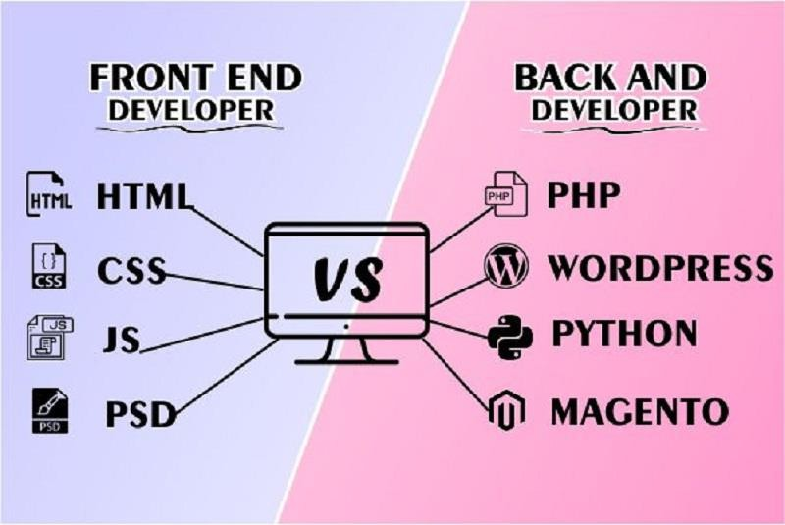

Front End Languages
The term "front-end language" typically refers to programming languages that are used to create the user interface (UI) and design of a website or web application. Front-end development involves everything that users interact with directly on a website, such as buttons, forms, navigation menus, and other visual elements.
- The primary front-end languages include: HTML (Hypertext Markup Language): HTML is the standard markup language for creating the structure and layout of web pages. It uses tags to define different elements on a page, such as headings, paragraphs, images, and links.
- CSS (Cascading Style Sheets): CSS is used for styling and formatting web pages. It allows developers to control the visual presentation of HTML elements, specifying aspects like color, layout, and typography.
- JavaScript: JavaScript is a versatile scripting language that enables interactive and dynamic features on a website. It is commonly used to create things like image sliders, form validation, and interactive content that responds to user actions.
These three languages (HTML, CSS, and JavaScript) form the core technologies for front-end development. Additionally, there are various frameworks and libraries, such as React, Angular, and Vue.js, that are built on top of JavaScript and provide additional tools and features to streamline the development process.

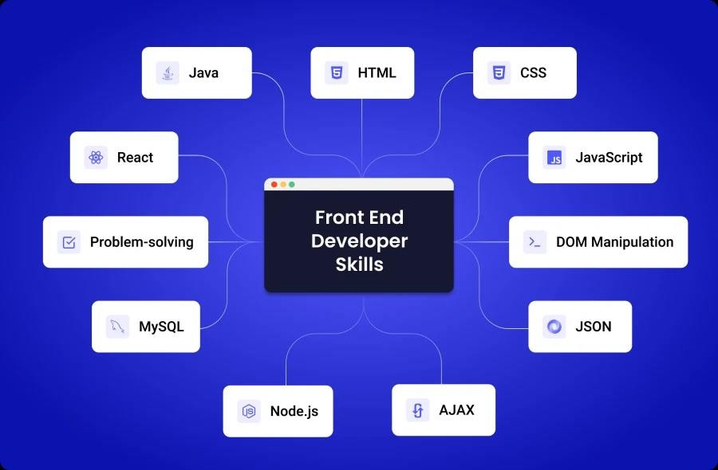

HTML Structure and Content

The HTML (Hyper Text Markup Language) structure, which establishes the site's layout and content, is the fundamental component of the architecture of the website. The HTML code is divided into a number of sections, each with a distinct function. Thelogical organization of the HTML structure guarantees a smooth and easy-to-use user experience.

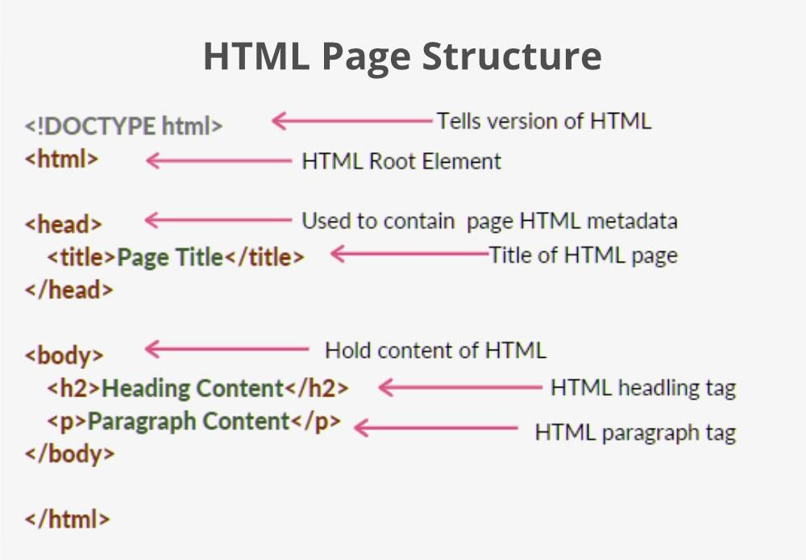

CSS Styling

The website's aesthetics are controlled by Cascading Style Sheets, or CSS, which are acrucial part of the frontend architecture. CSS not only defines the colour schemes, typography, and layout of the website, but it also ensures that the website is responsive.Through the use of responsive design principles, the website can seamlessly adapt to different screen sizes, making it useable on a range of devices, including PCs and mobile phones.

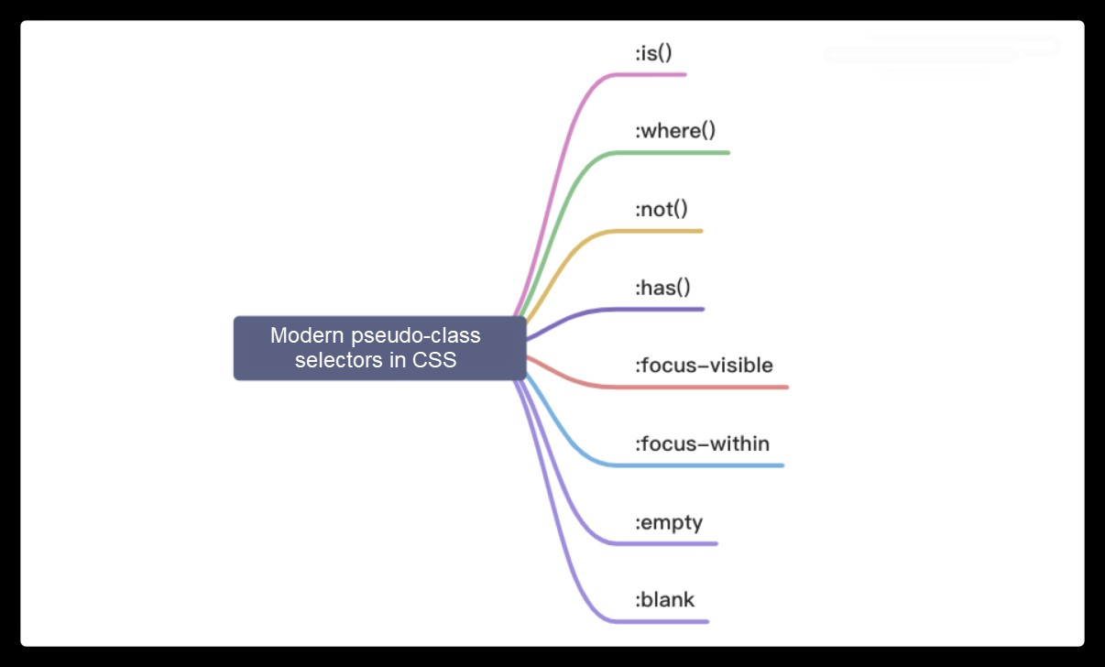

JavaScript Interactivity
JavaScript adds interactive elements and dynamic functionality to the front end. It is used to create features like responsive navigation menus, real-time updates, and interactive forms. By enabling features like interactive maps and image sliders, which boost user engagement, JavaScript makes sure the website offers more than just static content. This interactivity is necessary to produce an engaging and captivating user experience.

Implementation on website.

Creating a nou website involves several steps, including obtaining nou data, designing the user interface, and implementing the functionality. Below is a simplified example using HTML, CSS, and JavaScript.

Regular Updates: As new information becomes available.

Database: If you need to store historical weather data or user preferences, you may require a database. Consider databases like MySQL, PostgreSQL, or MongoDB.

PROBLEM IDENTIFY
Deidentifying problems on a Nou E-gyan website can involve various aspects related to data accuracy, user experience, functionality, and more. Here are some common problems that users might encounter on websites and suggestions on how to address them:

Inaccurate Data:
Issue: information is incorrect or outdated.
Solution: Ensure that the website pulls data from reliable and up-to-date sources. Regularly update the data to provide accurate and timely information.

Complex User Interface:
Issue: Users find it challenging to navigate the website or understand the displayed information.
Solution: Simplify the user interface, use clear labels, and provide tooltips or help sections. Prioritize essential information and make it easily accessible.

Slow Loading Times:
Issue: The website takes too long to load, affecting user experience.
Solution: Optimize images, minimize HTTP requests, and leverage browser caching. Consider using content delivery networks (CDNs) to improve loading times.

Limited Mobile Responsiveness:
Issue: The website is not optimized for mobile devices.
Solution: Ensure the website is responsive and functions well on various screen sizes. Implement a mobile-first design approach to enhance the user experience on smartphones and tablets.

Outdated Design:
Issue: The website has an outdated or unappealing design.
Solution: Update the website design to make it visually appealing and in line with modern web design standards. Consider user feedback to inform design changes.

Poor Accessibility:
Issue: The website is not accessible to users with disabilities.
Solution: Ensure compliance with accessibility standards (e.g., WCAG). Provide text alternatives for non-text content, ensure keyboard navigation, and use ARIA roles for interactive elements.

Inadequate Support and Help Documentation:
Issue: Users struggle to find help or support when needed.
Solution: Provide clear and easily accessible help documentation. Include FAQs, tutorials, and contact information for customer support.
Regularly gathering user feedback, conducting usability testing, and monitoring website analytics can help identify and address potential issues on a nou website.

CONCLUSION

Creating a conclusion for a Nou E-gyan website would depend on the specific content and purpose of the site. However, I can provide a general template that you can customize based on the key features and goals of your Nou E-gyan website:

In conclusion, our Nou E-gyan website aims to provide users with a comprehensive and user- friendly platform for accessing accurate and up-to-date information.

Key Features Recap:->
- Real-Time Updates: Our commitment to real-time updates ensures that users have the latest information at their fingertips, empowering them to make informed decisions.

- User-Friendly Interface: We prioritize user experience, offering an intuitive interface that caters to both novice and experienced users. The design focuses on simplicity without compromising on functionality.

- Mobile Accessibility: Our commitment to accessibility extends to mobile users, ensuring that individuals can access vital information anytime, anywhere, through responsive design.

- Looking Forward: As we move forward, we remain dedicated to enhancing our website's capabilities. We are actively exploring new features and technologies to further improve the accuracy, accessibility, and overall user experience. Your feedback is invaluable in this journey, and we invite you to be part of our community as we continue to evolve and refine our weather services.

FUTURE SCOPE

The system is flexible enough to ensure well coordinated efforts to face the strategic challenges emerging from rapidly changing economic environment and global trends. Facilities have been incorporated in the software so that online processing can be done easily and thus the effort and time can be saved.
- In future it is planned to develop our own web server to host the web application.
- Building Android Application for the system is also one of the future scope’s of this project.

References

- Andrews, J.W. 1993. Impact of weather event uncertainty upon an optimum ground-holding strategy. Air-Traffic Control Quarterly 1(1): 59–84.

- Belair, S., and Mailshot. 2001. Impact of horizontal resolution on the numerical simulation of a midlatitude squall line: Implicit versus explicit condensation. Mon. Weather Rev. 129:2362–2376.

- Benjamin, S.G., Jimbaran, K.J. Brundage, Beechworth, T.G. Smirnova, and T.L. Smith. 1998. The operational RUC-2. Preprints, 16th Conference on Weather Analysis and Forecasting, Phoenix, AZ, American Meteorological Society, pp. 249–252.

- Black, T.L. 1994. The new NMC mesoscale Eta model: Description and forecast examples. Weather Forecast 9:265–278.

- Carpenter, R.L., Jr., K. K. Droegemeier, G.M. Bassett, S.S. Weygandt, D. E. ahn, Stevenson, Equally, and Strasser. 1999. Storm-scale numerical weather prediction for commercial and military aviation, Part 1: Results from operational tests in 1998. Preprints, 8th Conference on Aviation, Range, and Aerospace Meteorology, January 10–15, American Meteorological Society, Dallas, TX, pp. 209–211.

- Droegemeier, K.K. 1997. The numerical prediction of thunderstorms: Challenges, potential benefits, and results from Realtime operational tests. WMO Bulletin 46:324–336.

- Evans, J. 2001. Tactical Weather Decision Support to Complement “Strategic” Traffic Flow Management for Convective Weather. Fourth International Air Traffic Management R&D Seminar ATM-2001, Santa Fe, NM. Available online at http://atm2001.eurocontrol.fr/ [accessed December 11, 2002].

- Suggested Citation: “References." National Research Council. 2003. Weather Forecasting Accuracy for FAA Traffic Flow Management: A Workshop Report. Washington, DC: The National Academies Press. Doi: 10.17226/10637. ×

- Forman, B.E., M.M. Wolfson, R.G. Hallowell, and M. P. Moore. 1999. Aviation user needs for convective weather forecasts. Preprints, Eighth Conference on Aviation, Range, and Aerospace Meteorology, Dallas, TX, American Meteorological Society, pp. 526–530.

- IPCC (International Panel on Climate Change). 1999. IPCC Special Report: Aviation and the Global Atmosphere. Jeepney, D.H. Lister, D.J. Griggs, D.J. Dokken, and McFarland, eds. Cambridge University Press, Cambridge, UK.

- Lorenz, E.N. 1969. The predictability of a flow which possesses many scales of motion. Tellus 21:289–307.

- Mass, C.F., Doves, Westrick, and B. A. Colle. 2002. Does increasing horizontal resolution produce more skilful forecasts? B. Am. Meteor. Soc. 83:407–430.

- Molinari, J. 1993. An overview of cumulus parameterizations in mesoscale models. Pp. 155–
158 in The Representation of Cumulus Convection in Numerical Models. American Meteorological Society, Boston.

- Sun, J., and N. A. Crook. 1998. Dynamical and microphysical retrieval from Doppler radar observations using a cloud model and its adjoint. Part II: Retrieval experiments of an observed Florida convective storm. J. Atmos. Sci. 55:835–852.

- Sun, J., and Narok. 2001. Real-time low-level wind and temperature analysis using WSR- 88D data. Weather Forecast. 16:117–132.

- Wang, D., K. K. Droegemeier, D. Jahn, K. Mx, MXIE, and Zhang. 2001. NIDS-based intermittent diabatic assimilation and application to storm-scale numerical weather prediction. Preprints, 14th Conference on Numerical Weather Prediction, July 30-August 2, American Meteorological Society, Fort Lauderdale, Fla., pp. J125–J128.

- Weygandt, S.S., A. Shapiro, and K. K. Droegemeier. 2002. Retrieval of initial forecast fields from single-Doppler observations of a supercell thunderstorm. Part II: Thermodynamic retrieval and numerical prediction. Mon. Weather Rev 130:454–476.

- Wilkes, D.S. 1995. Statistical Methods in the Atmospheric Sciences. San Diego: Academic Press, 467pp.

- Xue, M., D.H. Wang, J. D. Gao, Brewster, and K.K. Droegemeier. 2003. The Advanced Regional Prediction System (ARPS), storm-scale numerical weather prediction and data assimilation. Meteor. Atmos. Phys.

- National Academies of Sciences, Engineering, and Medicine. 2003. Weather Forecasting Accuracy for FAA Traffic Flow Management: A Workshop Report. Washington, DC: The National Academies Press. https://doi.org/10.17226/10637.

